Guided Capstone Project Report

# Ticket Prediction Summary

* The data provided revealed no correlation between the ticket price and the state the resort is in, because of this, we looked carefully into other variables and treated all resorts equally.
* The variables that drive the ticket prices are: vertical_drop, Snow Making_ac, total_chairs, fastQuads, Runs, LongestRun_mi, trams, and SkiableTerrain_ac.

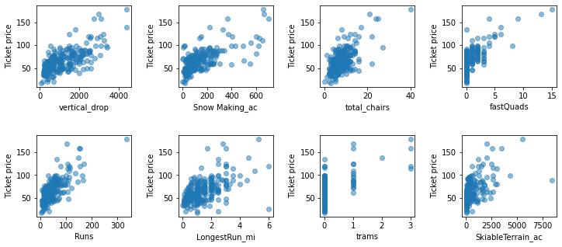

Predictors vs. ticket price

* From these variables, we were able to predict a ticket price of $95.87 (+- $10.39) for Big Mountain. We also determined that Big Mountain is a high tier resort, being amongst the top resorts when it comes to the quantity of amenities (predictor variables) they have to offer. This is why the predicted price was $14.87 (+- $10.39) above the current ticket price.
* The new lift costs $1,540,000 to operate, that equates to $0.88 per ticket (on the basis of each visitor on average buying 5-day tickets). The proposed new price strategy will easily cover this increase in operational cost.

# Business Options and Recommendations

The business has shortlisted some options:

1. Permanently closing down up to 10 of the least used runs. This doesn't impact any other resort statistics.

2. Increase the vertical drop by adding a run to a point 150 feet lower down but requiring the installation of an additional chair lift to bring skiers back up, without additional snow making coverage.

3. Same as number 2, but adding 2 acres of snow making cover.

4. Increase the longest run by 0.2 mile to boast 3.5 miles length, requiring an additional snow making coverage of 4 acres.

## Scenario 1 Analysis

From our analysis we can conclude:

* Closing 3 to 5 runs will have the same impact on ticket price. Therefore, closing 5 runs will lead to more savings.
* Closing 6 to 8 runs will have the same impact on ticket price, however, the ticket price will be affected around double compared to closing 3 to 5 runs.

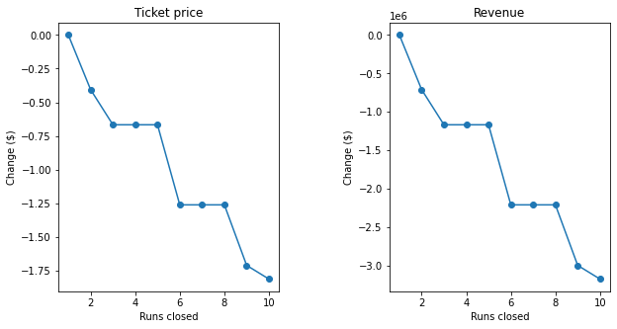

## Scenario 2 Analysis

This scenario increases support for ticket price by $1.99. Over the season, this could be expected to amount to $3,474,638.

## Scenario 3 Analysis

This scenario increases support for ticket price by $1.99. Over the season, this could be expected to amount to $3,474,638.

## Scenario 4 Analysis

This scenario makes no difference whatsoever for ticket price, yielding no revenues.

## Recommendations

* A combination of Scenarios 1 & 2 may have better results: 5 least used runs are closed, and a 6th one is modified to increase vertical drop by 150 feet. Whether or not a new chair will be needed or an existing one can be repurposed will need further analysis.
* Closing 5 runs will have an impact on the ticket price of around -$0.75 and cost of operation associated with them.
* Increasing the vertical drop by adding a run to a point 150 feet will increase ticket price by $1.99 ($3,474,638 projected for the year), but will require the installation of an additional chair lift to bring skiers back up (which, based on the newly installed chair) will increase operation cost by $1,540,000.